1. Deploy Services to Azure Container Apps

* Screenshots of the configuration process for each Container App instance (PetStoreApp, PetService, ProductService, OrderService) on the "Basics", "Container", and "Ingress" tabs.

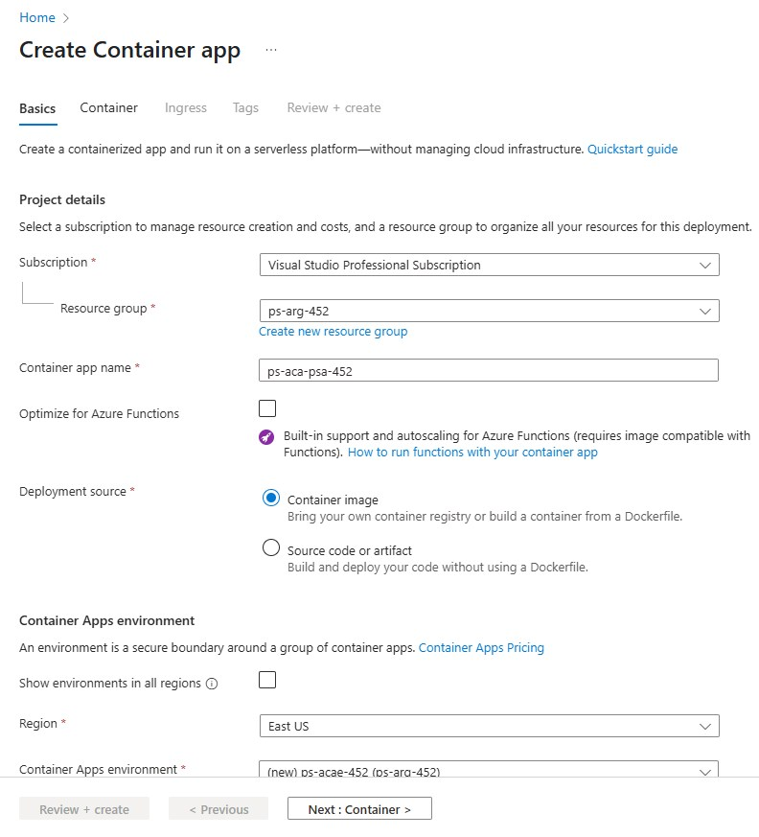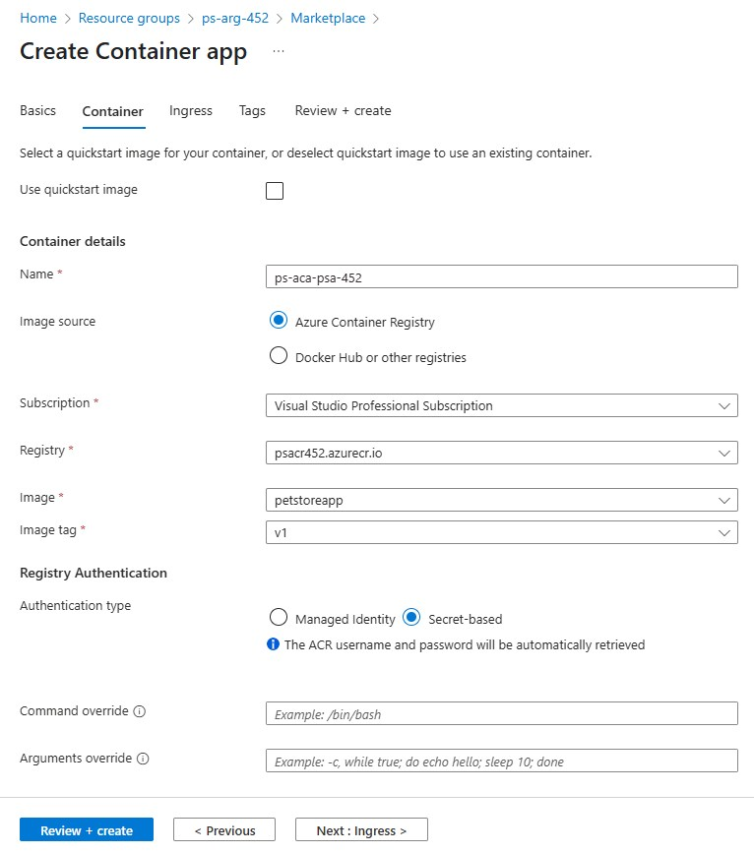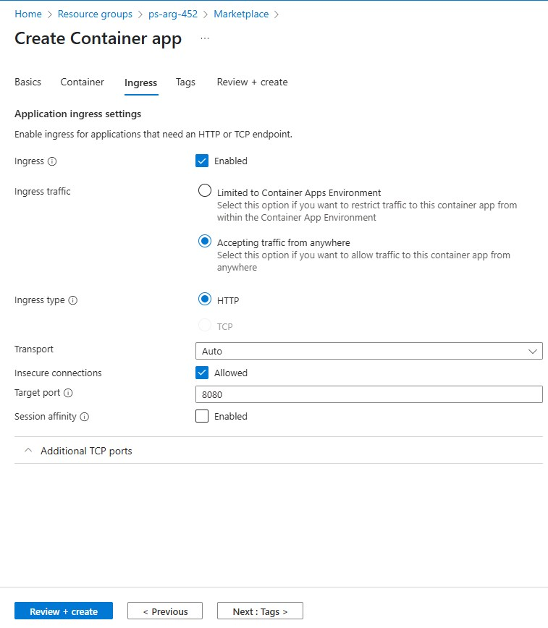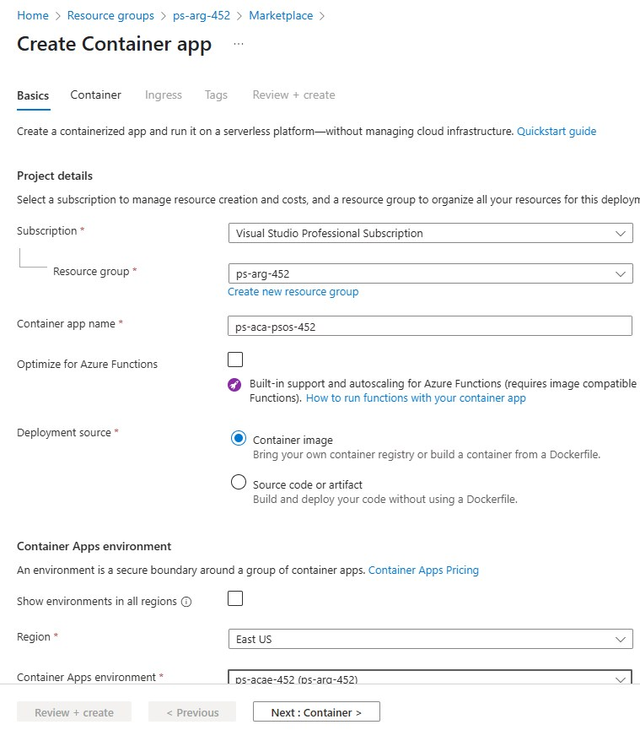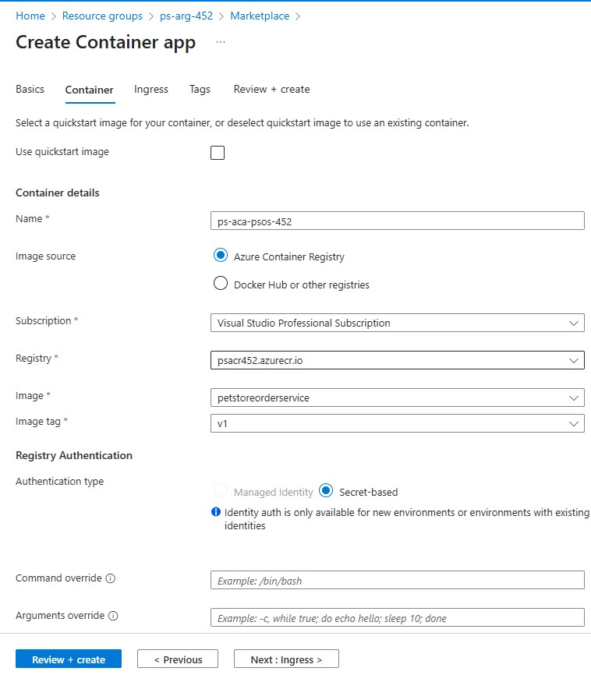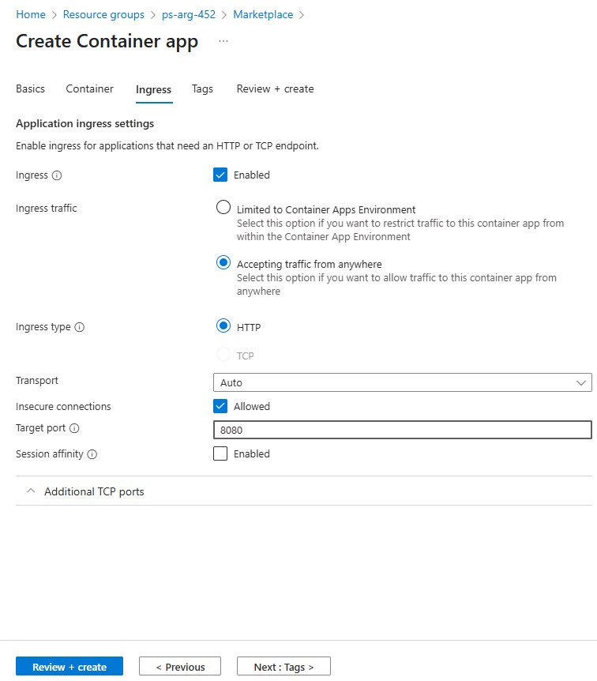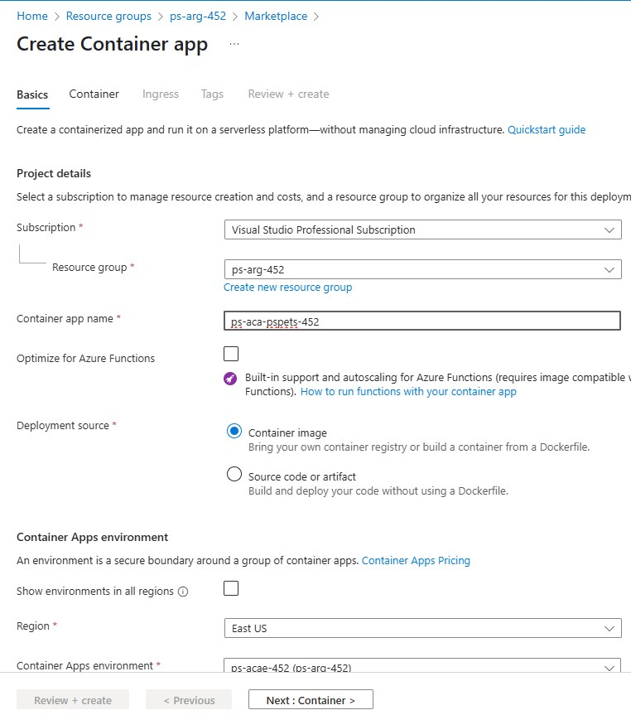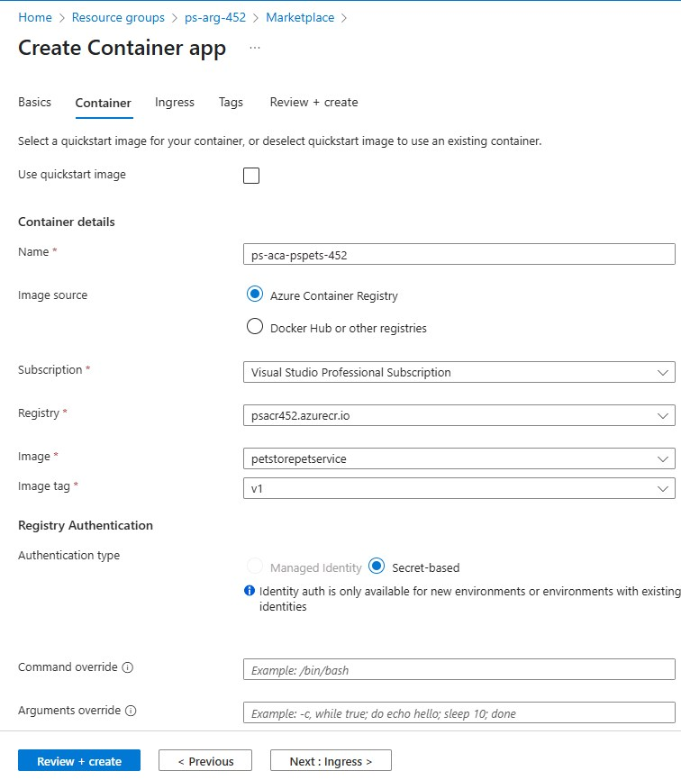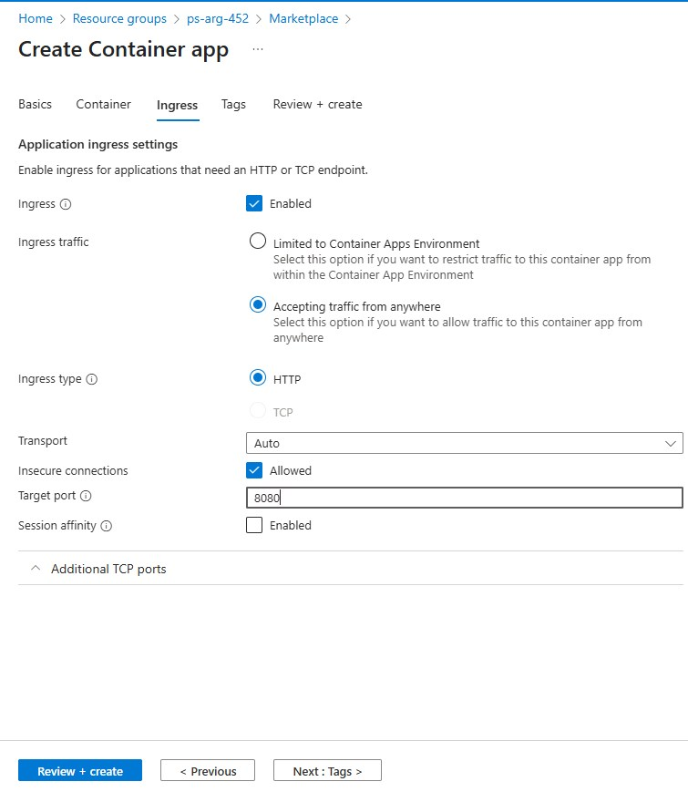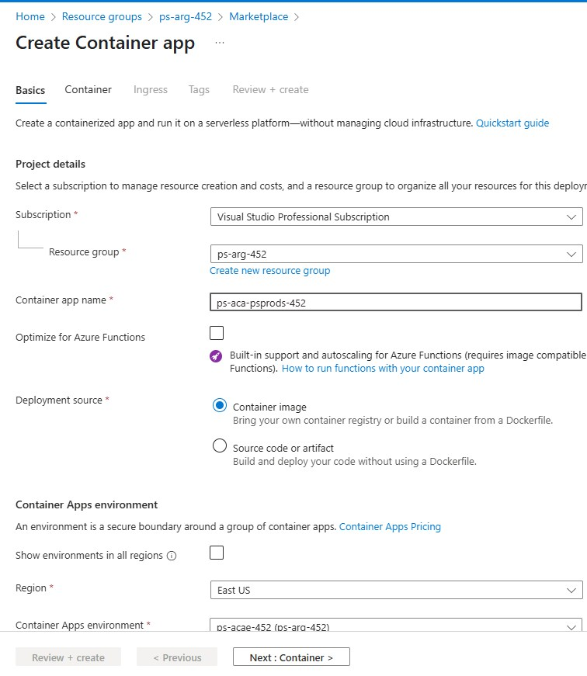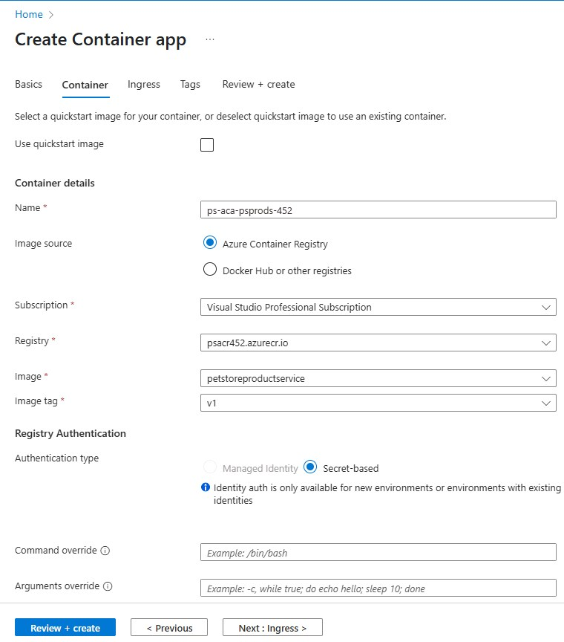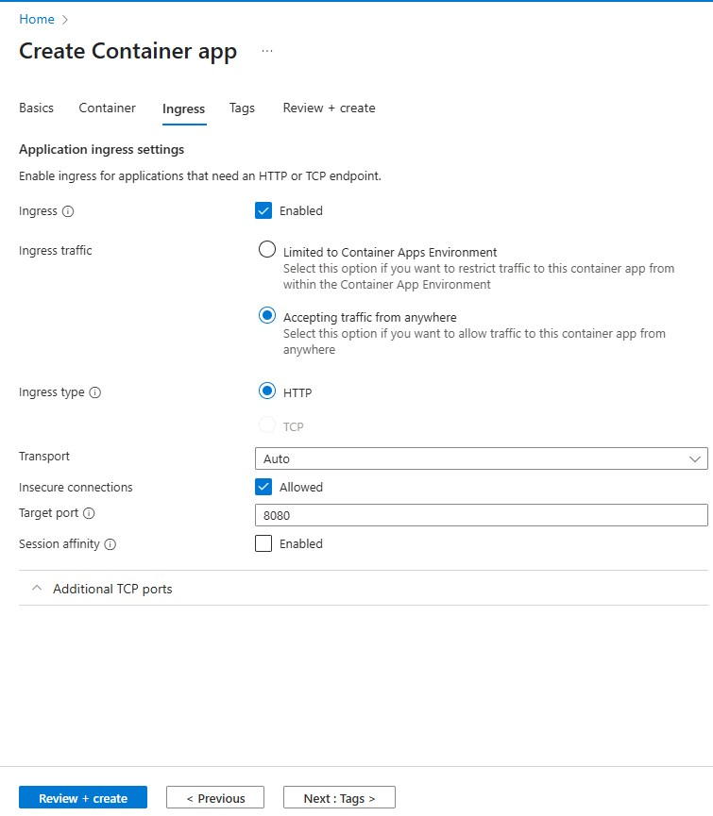

* Screenshot showing the successful creation of each Container App instance.

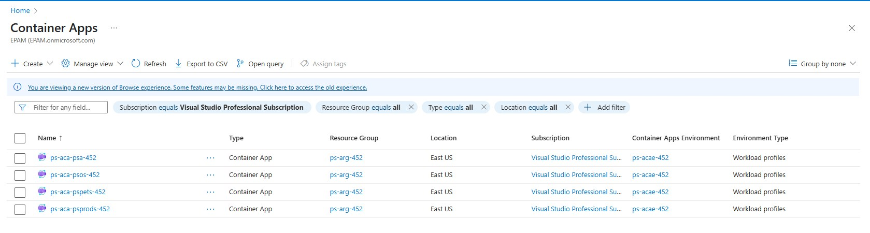

1. Configure Environment Variables

* Screenshots of the Application URLs from the "Overview" tab.

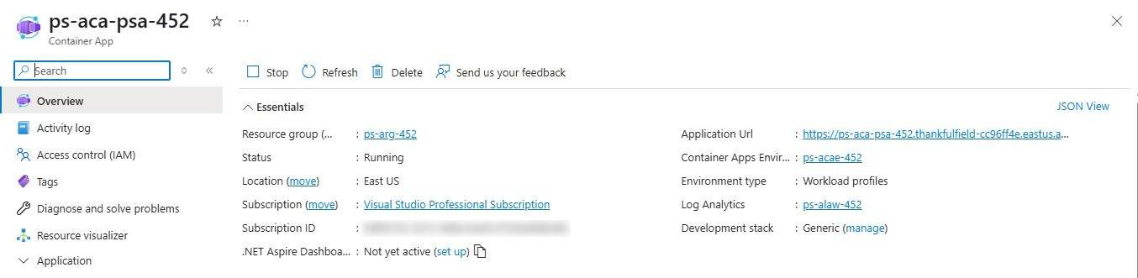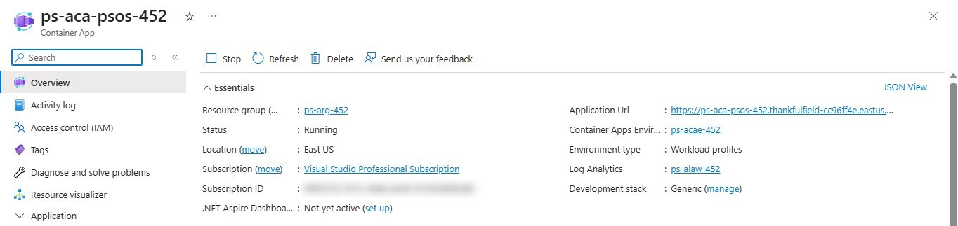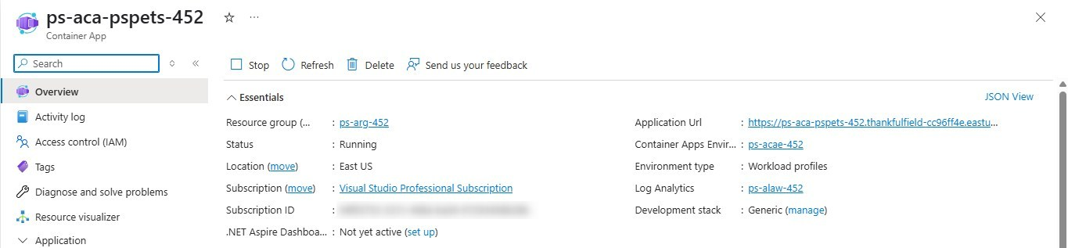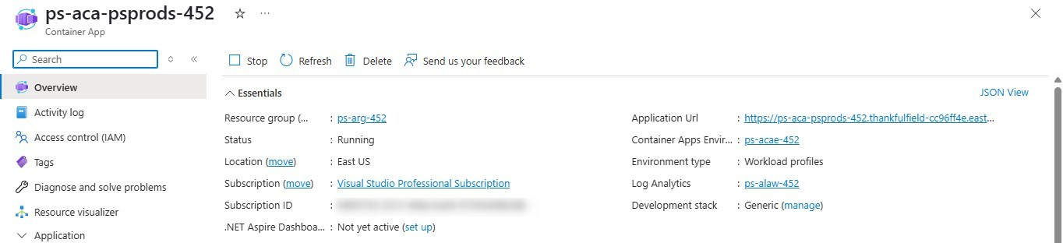

* Screenshots showing the process of adding environment variables in the "Environment Variables" section.

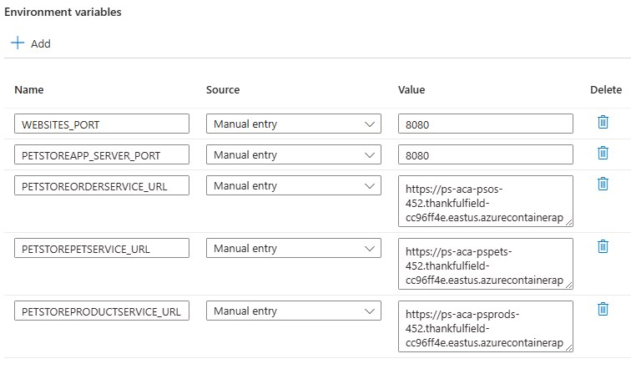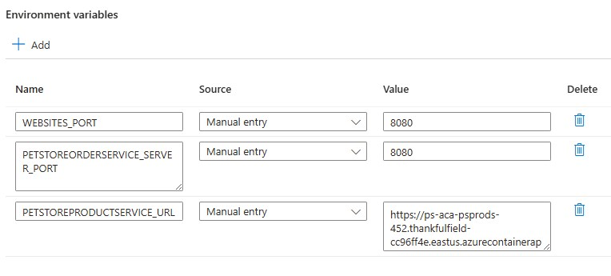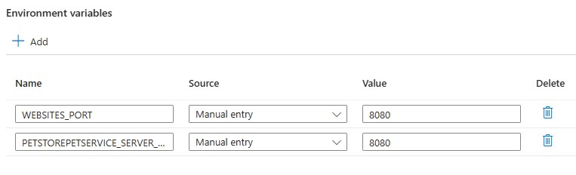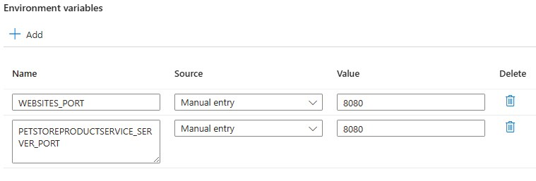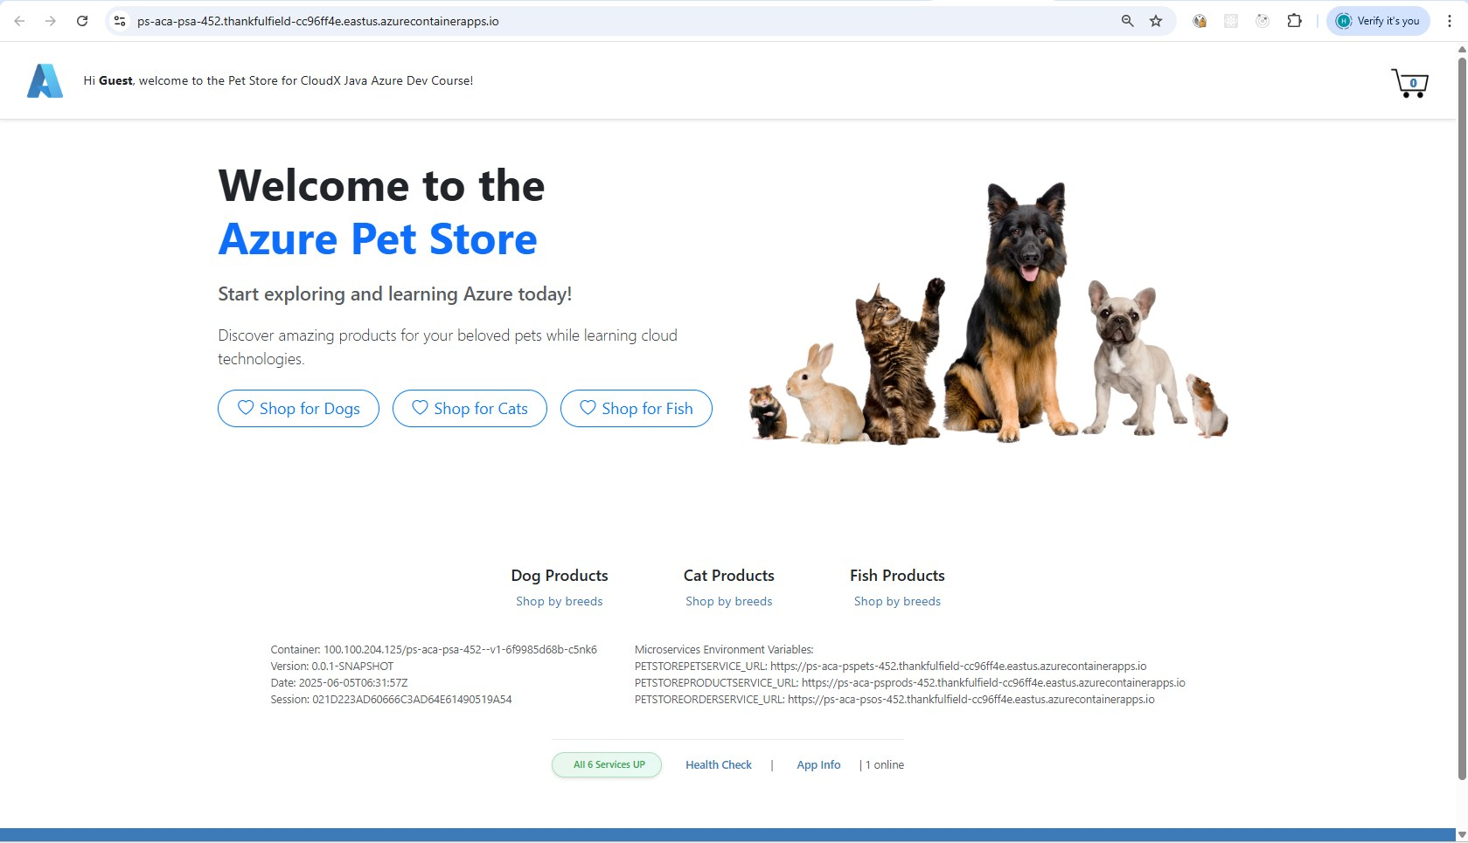

1. Configure Autoscaling

* Screenshots of the "Scale and replicas" settings for each Container App (PetStoreApp, PetService, ProductService, OrderService).
* Screenshots of the "Add scale rule" configuration for HTTP scaling and concurrent requests settings.

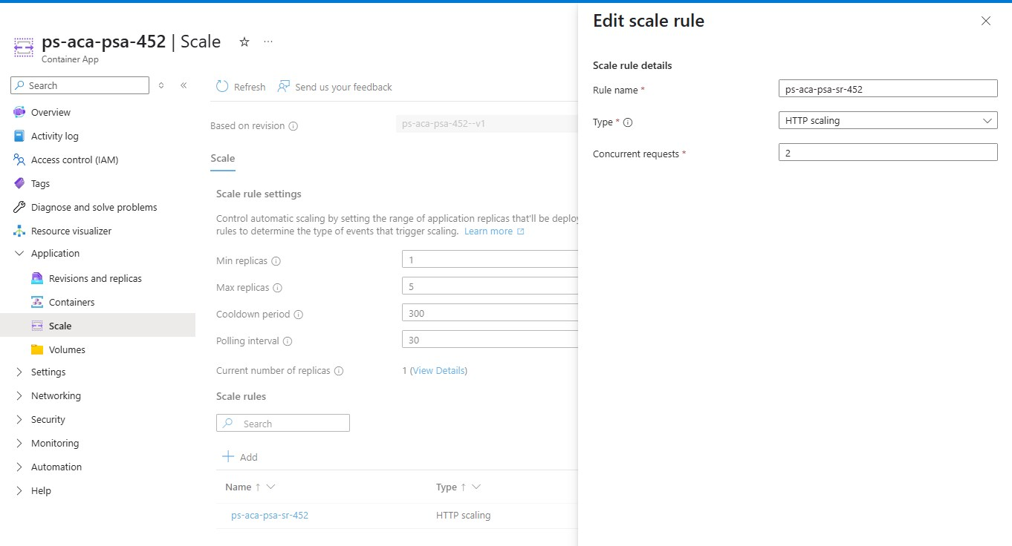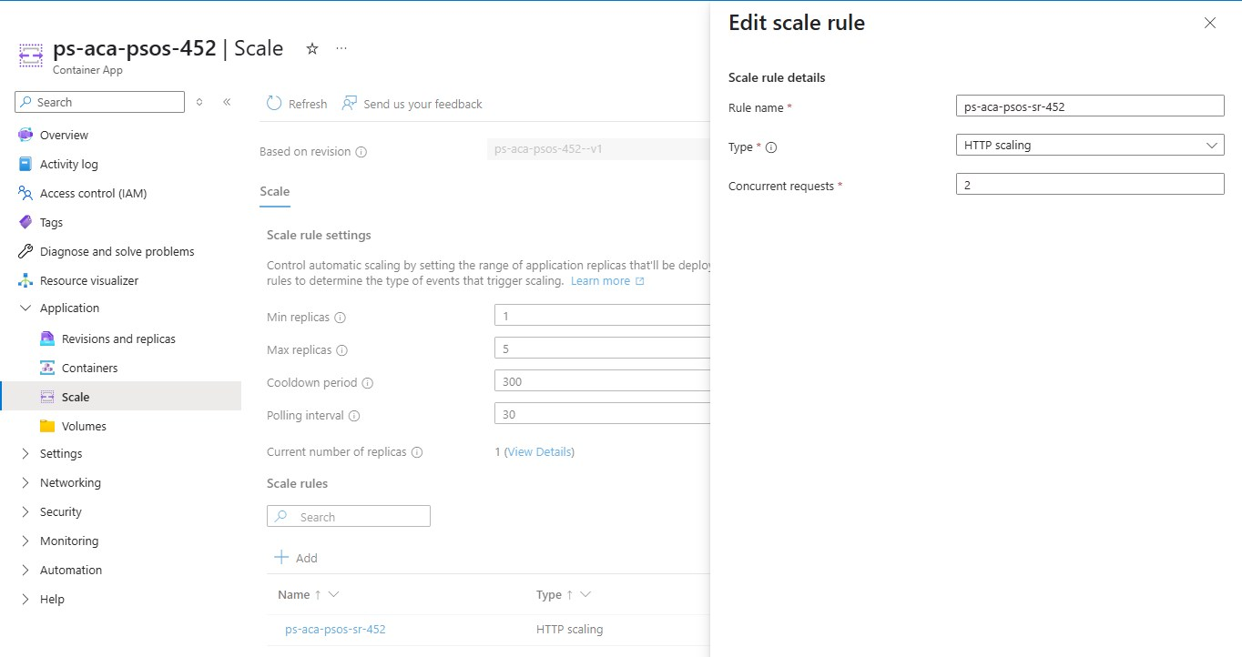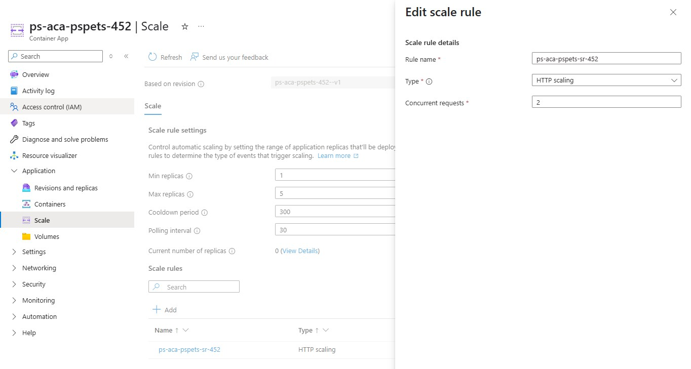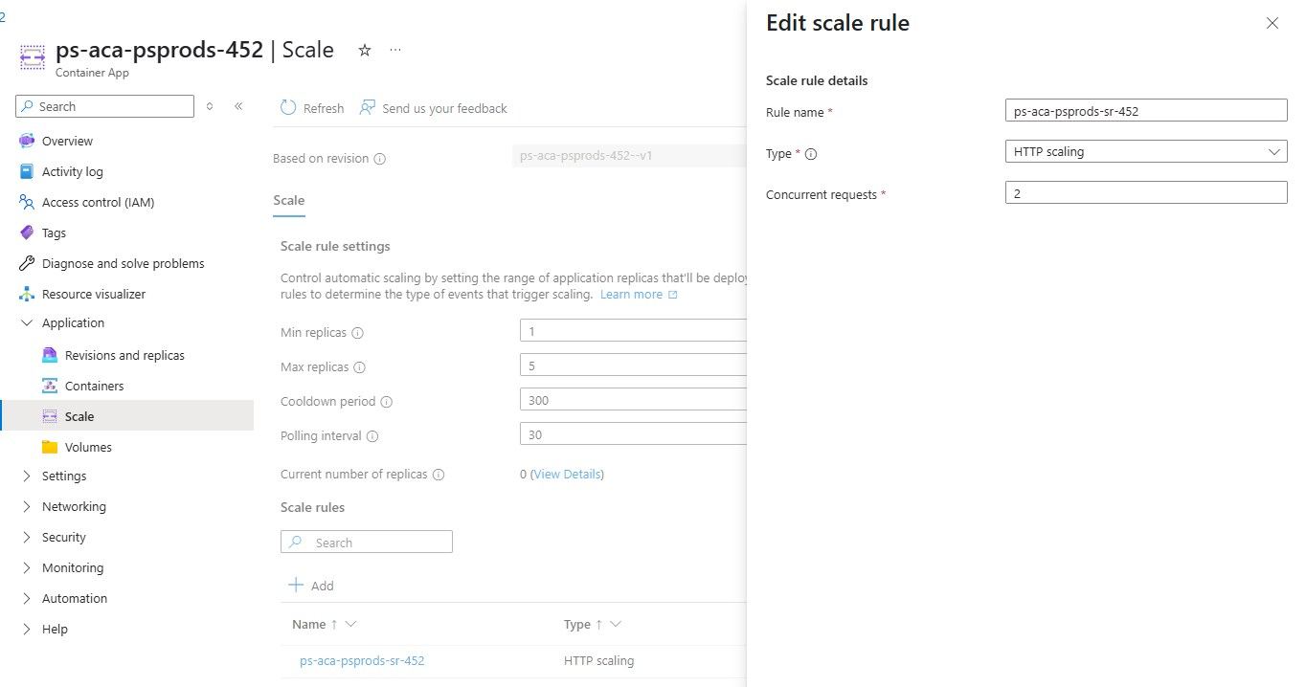

1. Test Autoscaling using k6 Tool

* Screenshots of the k6 tool in use for testing autoscaling.

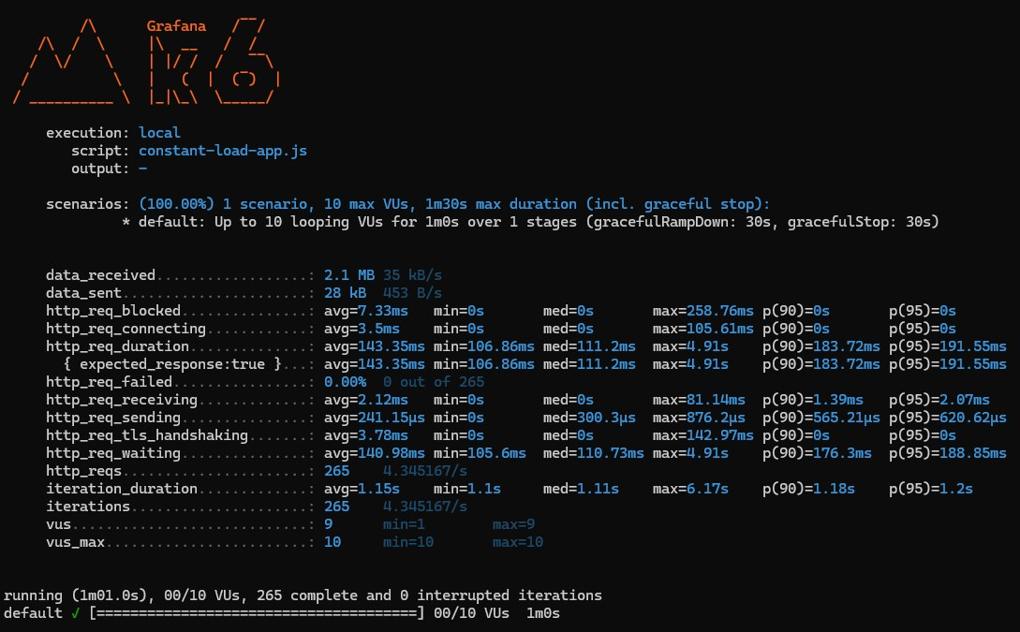 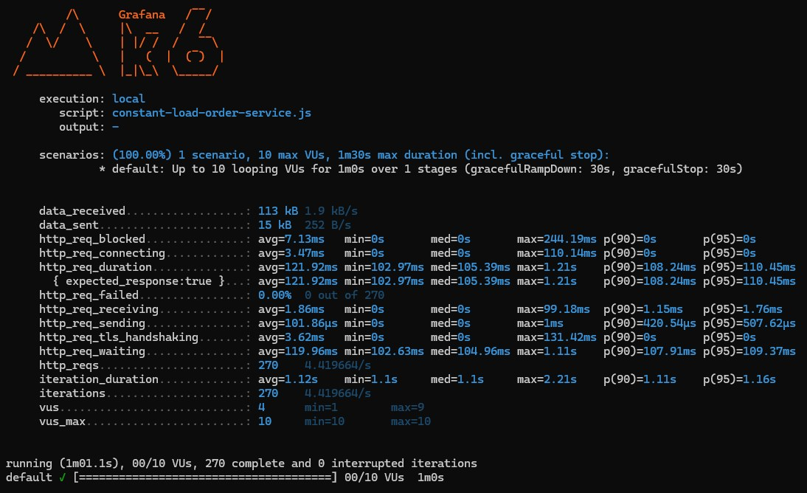 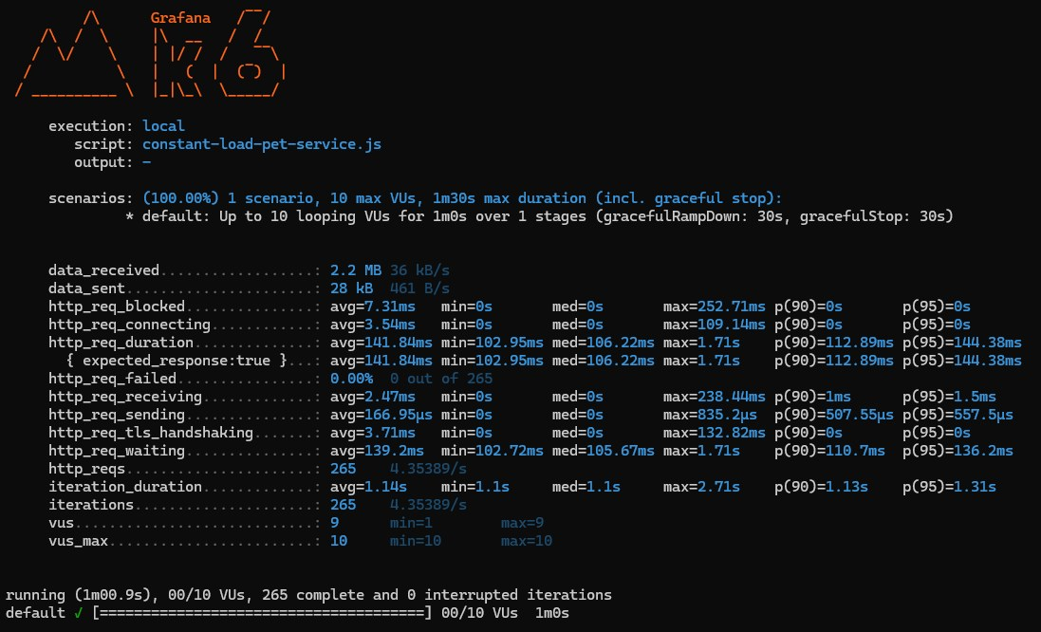 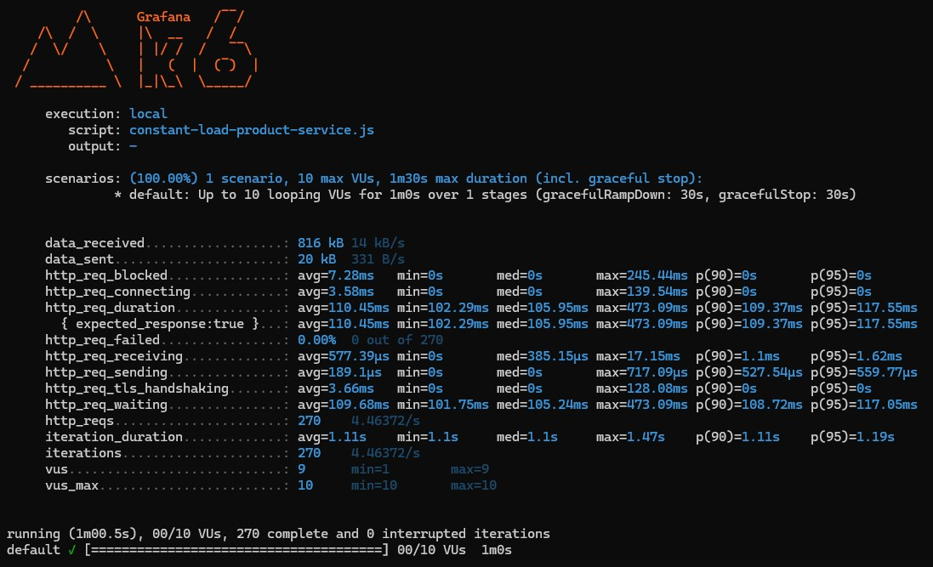 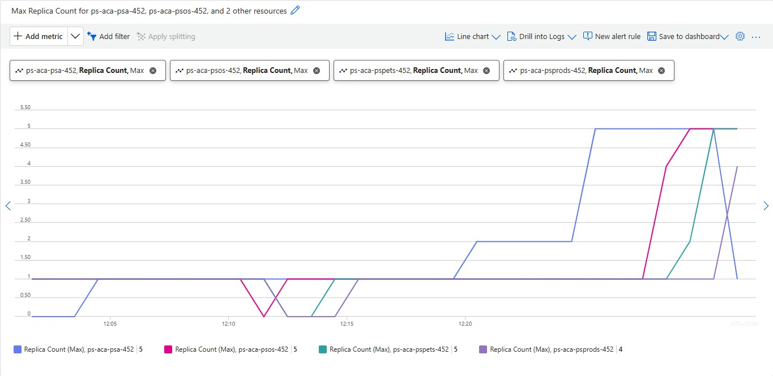

1. Deploy Multiple Revisions Simultaneously for PetStoreApp

* Screenshot showing the "Revisions" settings with "Multiple" selected as the Revision Mode for the PetStoreApp.

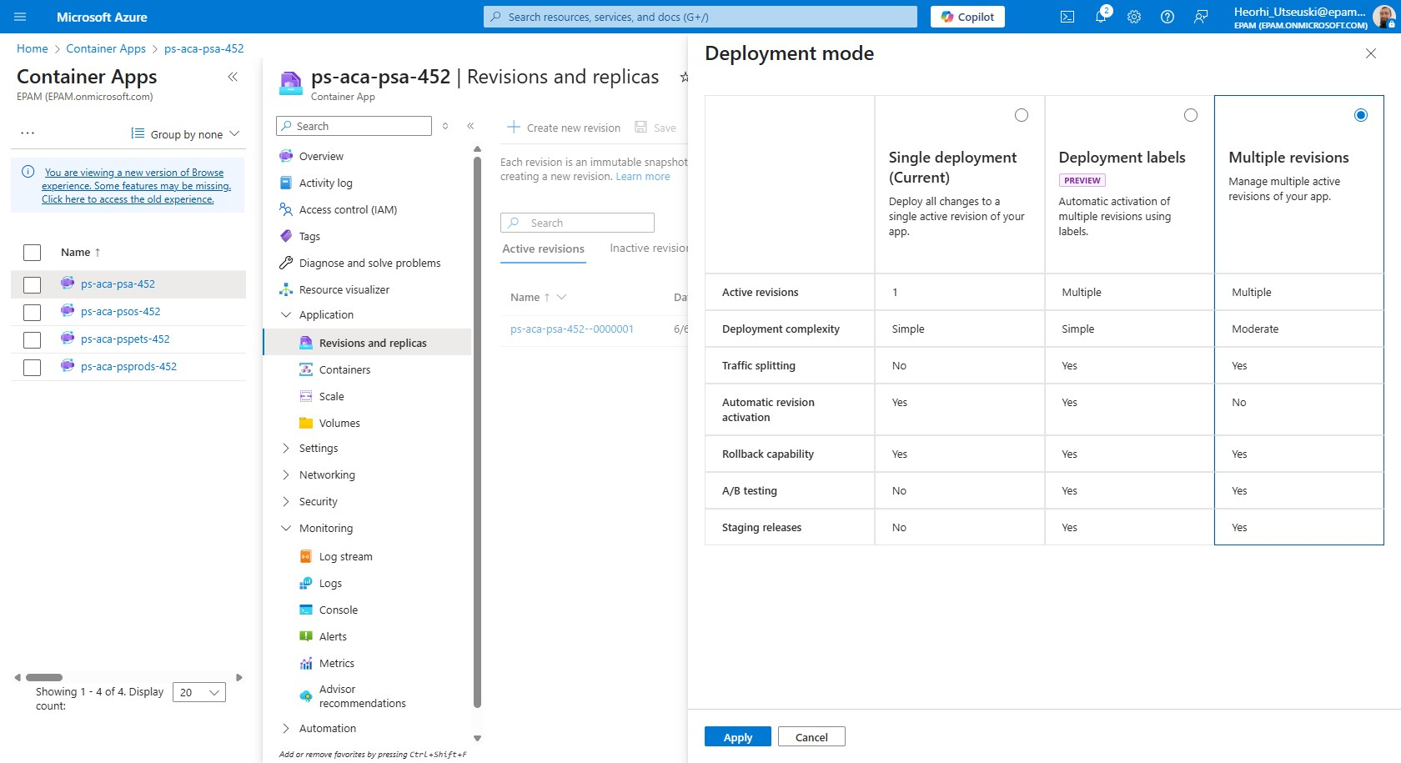 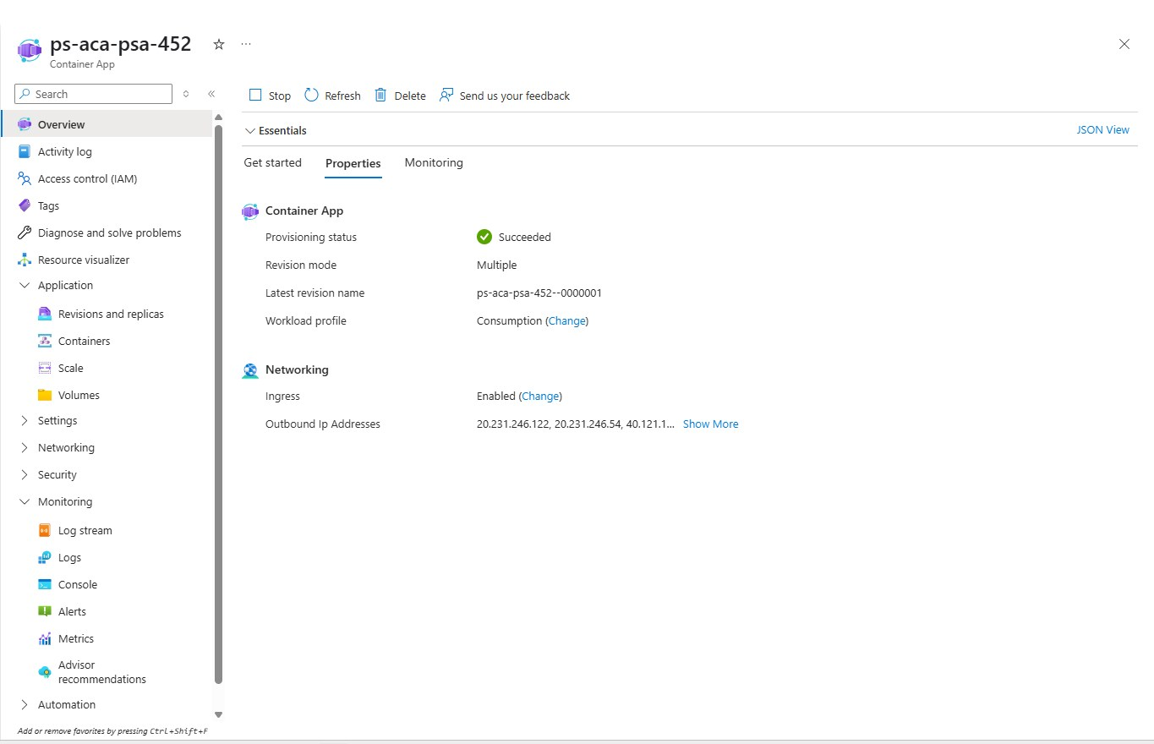

* Screenshots of the "Create new revision" process, including updating the container image tag and the creation of the new revision.

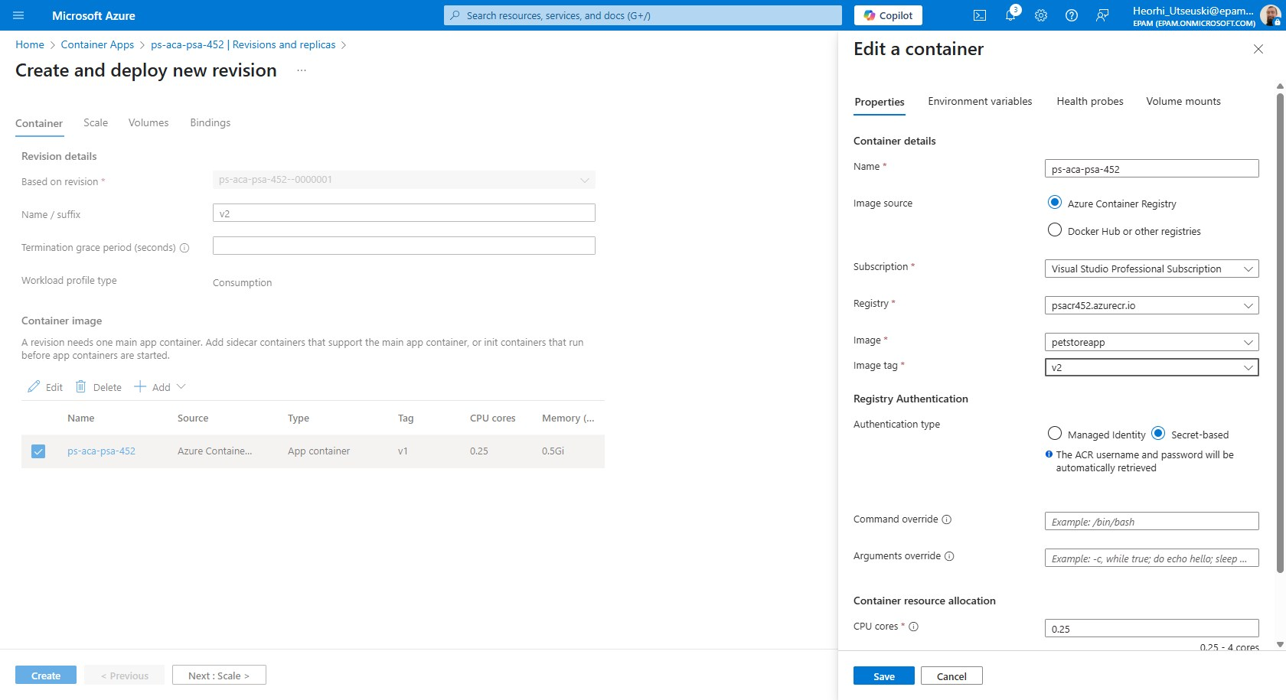

* Screenshots showing the traffic distribution settings under "Active revisions" for Canary deployment.

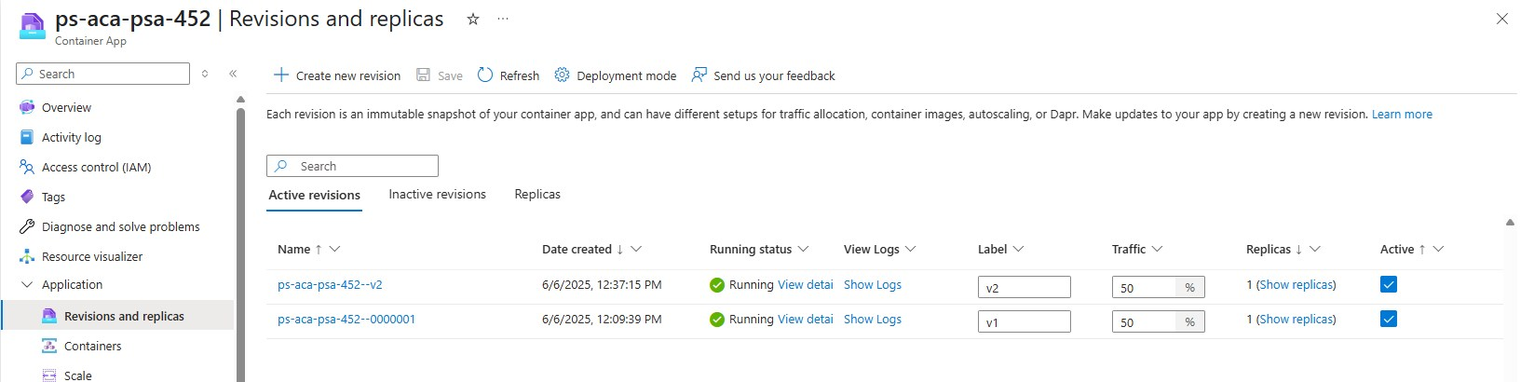

* Screenshots of the final traffic distribution settings for Blue/Green deployment, with 100% traffic directed to the new revision.

